MASS SPECTROMETRY
Mass spectrometry is a powerful analytical technique used to quantify known materials, to identify unknown compounds within a sample, and to elucidate the structure and chemical properties of different molecules. The complete process involves the conversion of the sample into gaseous ions, with or without fragmentation, which are then characterized by their mass to charge ratios (m/z) and relative abundances.
This technique basically studies the effect of ionizing energy on molecules. It depends upon chemical reactions in the gas phase in which sample molecules are consumed during the formation of ionic and neutral species.
Mass to charge ratio (m/z): In mass spectroscopy, the mass-to-charge ratio (symbols: m/z, m/e) of a cation is equal to the mass of the cation divided by its charge.
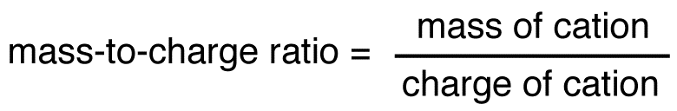
Since the charge of cation formed in the mass spectrometer is almost always +1, the mass-to-charge ratio of a cation is usually equal to the mass of the cation.
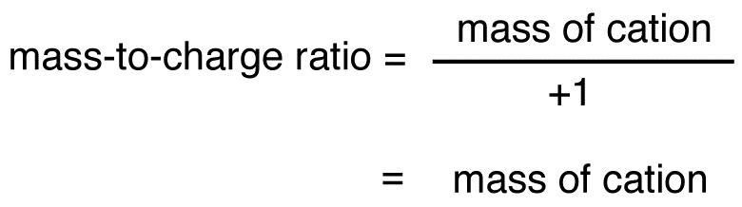
The mass of the molecular ion is equal to the molecular weight of the compound. Thus, the mass-to-charge ratio of the molecular ion is equal to the molecular weight of the compound.
Relative abundance (relative intensity):: The y-axis of a mass spectrum quantifies the amount of an ion produced in relation to the amount of the most abundant ion (the base peak).
BASIC PRINCIPLE
A mass spectrometer generates multiple ions from the sample under investigation, it then separates them according to their specific mass-to-charge ratio (m/z), and then records the relative abundance of each ion type.
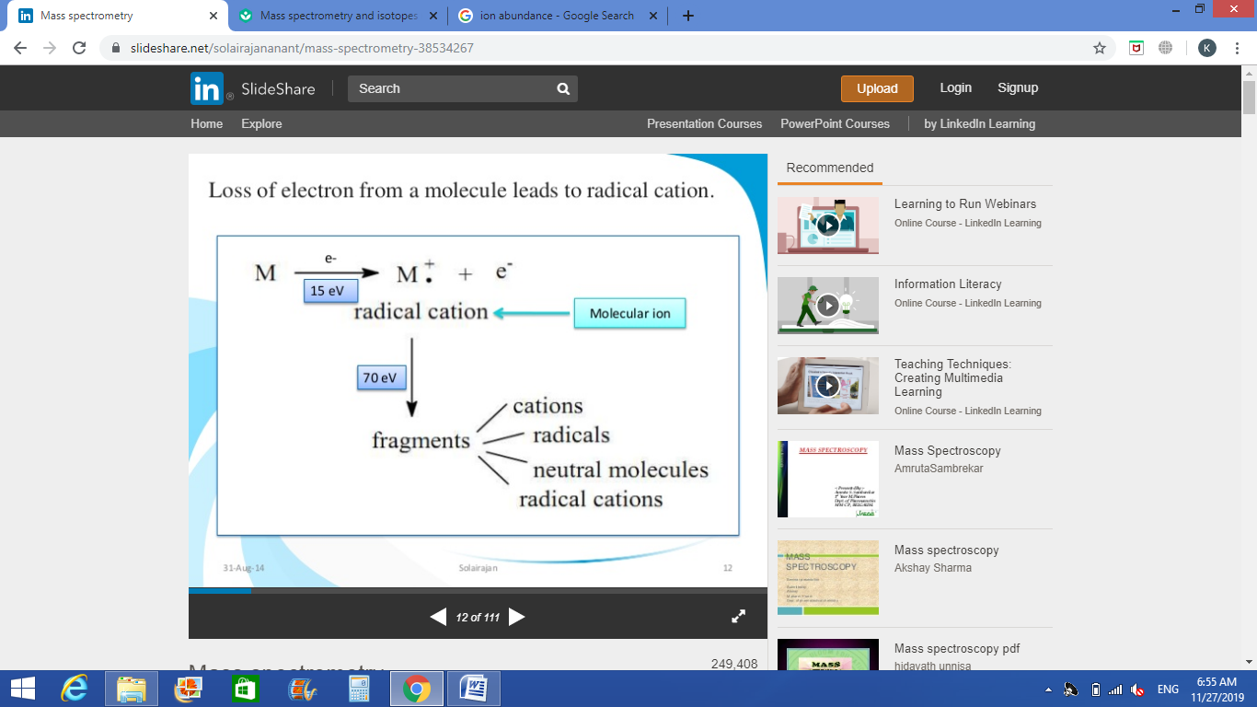
The first step in the mass spectrometric analysis of compounds is the production of gas phase ions of the compound, basically by electron ionization. This molecular ion undergoes fragmentation. Each primary product ion derived from the molecular ion, in turn, undergoes fragmentation, and so on. The ions are separated in the mass spectrometer according to their mass-to-charge ratio, and are detected in proportion to their abundance.

A mass spectrum of the molecule is thus produced. It displays the result in the form of a plot of ion abundance versus mass-to-charge ratio. Ions provide information concerning the nature and the structure of their precursor molecule. In the spectrum of a pure compound, the molecular ion, if present, appears at the highest value of m/z (followed by ions containing heavier isotopes) and gives the molecular mass of the compound.

WORKING OF MASS SPECTROMETER
Atoms and molecules can be deflected by magnetic fields - provided the atom or molecule is first turned into an ion. Electrically charged particles are affected by a magnetic field although electrically neutral ones aren't. The atom or molecule is ionized by knocking one or more electrons off to give a positive ion. This is true even for things which you would normally expect to form negative ions (chlorine, for example) or never form ions at all (argon, for example). Most mass spectrometers work with positive ions. The ions are accelerated so that they all have the same kinetic energy. The ions are then deflected by a magnetic field according to their masses. The lighter they are, the more they are deflected. The amount of deflection also depends on the number of positive charges on the ion - in other words, on how many electrons were knocked off in the first stage. The more the ion is charged, the more it gets deflected. The beam of ions passing through the machine is detected electrically.
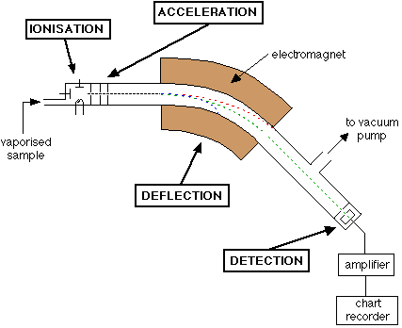

INSTRUMENTATION
Mass spectrometry uses an instrument called a mass spectrometer. The main components of a mass spectrometer are:
- Inlet system
- Ion source
- Mass analyzer
- Detector
Inlet system: Samples can be introduced to the mass spectrometer directly via solids probe, or in the case of mixtures, by the intermediary of chromatography device (e.g. Gas chromatography, Liquid chromatography, Capillary electrophoresis, etc).
Ion source: Ion source cause the ionization of compounds by different methods, such as electron impact ionization, chemical ionization, electrospray ionization technique etc.
Electron impact ionization: EI ionization method is suitable for non-thermolabile compounds. The volatility of the sample is required. Sample molecules in vapor state are bombarded by fast moving electrons, conventionally 70 eV energy. This results in ion formation. One electron from the highest orbital energy is dislodged, and as a consequence molecular ions are formed. Some of these molecular ions decompose and fragment ions are formed. The fragmentation of a given ion is due to the excess of energy that it requires within the ionization.
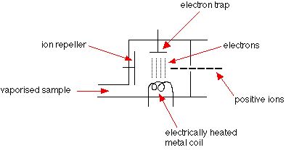
Chemical ionization: Chemical Ionization (CI) is especially useful technique when no molecular ion is observed in EI mass spectrum, and also in the case of confirming the mass to charge ratio of the molecular ion. Chemical ionization technique uses virtually the same ion source device as in electron impact, except, CI uses tight ion source, and reagent gas. Reagent gas (e.g. ammonia) is first subjected to electron impact. Sample ions are formed by the interaction of reagent gas ions and sample molecules. This phenomenon is called ion-molecule reactions. Reagent gas molecules are present in the ratio of about 100:1 with respect to sample molecules. Positive ions and negative ions are formed in the CI process. Depending on the setup of the instrument (source voltages, detector, etc...) only positive ions or only negative ions are recorded.
Negative Ion Chemical Ionization: This can be achieved by different mechanisms such as:
- Electron capture reaction due to attainment of slow moving, low energy "thermalized" electrons which may be transferred more efficiently to sample molecules.
- Electron transfer from ionized reagent gas (e.g. NH₂⁻ may transfer an electron to a molecule having a greater electron affinity than NH₂).
Molecular ions observed in negative ion chemical ionization mass spectra are usually M⁻ or [M-H]⁻.
Mass analyzer: It separates different ions based on their molecular weight. Different types of mass analyzers are used such as magnetic sector, ion trap, quadrupole etc.
Magnetic sector: The sector mass spectrometer was one of the most common types of mass analyser and probably the most familiar to the everyday scientist. Ions enter the instrument from the source (bottom left) where they are initially focussed. They enter the magnetic sector through the source slit where they are deflected according to the left-hand rule.
Different ions are deflected by the magnetic field by different amounts. The amount of deflection depends on the mass of the ion and charge on the ions. Lighter ions are deflected more than heavier ones while ions with 2 (or more) positive charges are deflected more than ones with only 1 positive charge. Scanning the magnet enables ions of different masses to be focused on the monitor slit. At this stage, the ions have been separated only by their masses.
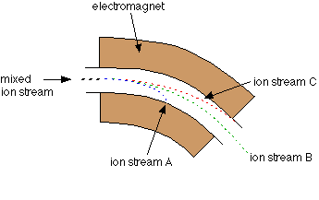
Detector: Typically, some type of electron multiplier is used. When an ion hits the metal box, its charge is neutralised by an electron jumping from the metal on to the ion. That leaves a space amongst the electrons in the metal, and the electrons in the wire shuffle along to fill it. A flow of electrons in the wire is detected as an electric current which can be amplified and recorded. The more ions arriving, the greater the current.
Only ion stream B makes it right through the machine to the ion detector. The other ions collide with the walls where they will pick up electrons and be neutralised. Eventually, they get removed from the mass spectrometer by the vacuum pump.
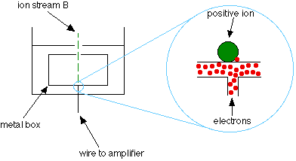
INTERPRETATION OF MASS SPECTRUM
Usually the first strategy for identifying an unknown compound is to compare its experimental mass spectrum against a library of mass spectra. If no matches result from the search, then manual interpretation or software assisted interpretation of mass spectra must be performed.
A mass spectrum will usually be presented as a vertical bar graph, in which each bar represents an ion having a specific mass-to-charge ratio (m/z) and the length of the bar indicates the relative abundance of the ion. The most intense ion is assigned an abundance of 100, and it is referred to as the base peak. Most of the ions formed in a mass spectrometer have a single charge, so the m/z value is equivalent to mass itself. Modern mass spectrometers easily distinguish (resolve) ions differing by only a single atomic mass unit (amu), and thus provide completely accurate values for the molecular mass of a compound. The highest-mass ion in a spectrum is normally considered to be the molecular ion, and lower-mass ions are fragments from the molecular ion, assuming the sample is a single pure compound.
The following diagram displays the mass spectra of two simple gaseous compounds, carbon dioxide and propane. The molecules of these compounds are similar in size, i.e., CO₂ and C₃H₈ both have a nominal mass of 44 amu.
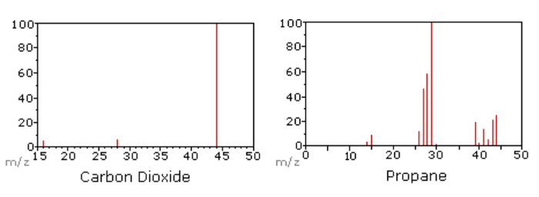
Since a molecule of carbon dioxide is composed of only three atoms, its mass spectrum is very simple. The molecular ion is also the base peak, and the only fragment ions are CO (m/z=28) and O (m/z=16). The molecular ion of propane also has m/z=44, but it is not the most abundant ion in the spectrum. Cleavage of a carbon-carbon bond gives methyl and ethyl fragments, one of which is carbocation and the other a radical. Both distributions are observed, but the larger ethyl cation (m/z=29) is the most abundant, possibly because its size affords greater charge dispersal.
TYPES OF IONS PRODUCED DURING IONIZATION / FRAGMENTATION
Different ions produced during ionization/fragmentation are molecular ion or parent ion, fragment ions, rearrangement ions, multicharged ions and negative ions.
Molecular ion: When a molecule is bombarded with electrons in high vacuum in Mass spectrometer, it is converted into positive ions by loss of an electron. These ions are called Molecular or Parent ions.
M + e → M⁺ + 2e
Where, M represents the Molecule; M⁺ represents the Molecular or Parent ion. The order of energy required to remove electron is as follows:
σ electrons > non-conjugated π > conjugated π > nonbonding or lone pair of electrons
Molecular peak is observed if molecular ions remain intact long enough (10⁻⁶ seconds) to reach the detector. This peak gives the molecular weight of the compound. The molecular ion peak is usually the peak of the “highest mass number”. Molecular ion peak gives the molecular weight of the compound.
Fragment ions: When the energy is given to Molecular ion during electron impact, further cleavage takes place and ions of lower mass number known as Fragment ions are produced.
M⁺ → M⁺₁ + M₂
Rearrangement ions: Rearrangement ions are the fragments whose origin cannot be described by simple cleavage of bonds in the parent ion, but are result of intramolecular atomic rearrangement during fragmentation. These are probably due to recombination of fragment ions and known as rearrangement peaks.
Multi charged ions: Sometimes ions may also exist with two or three charges instead of usual single charge in the mass spectrum. These are known as doubly or triply charged ions. They are created as follows:
M⁺ + e⁻ → M⁺⁺ + 3e
But under normal operating conditions, most of the ions produced are single charged. The doubly or triply charged ions are recorded at a half or one third of the m/e value of the single charged ions.
Negative ions: The positive ions predominate in electronic impact ionization because of greater stability. Negative ions are not very useful in structural determinations. The formation of Negative ions is very rare but these can be produced in three ways:
- AB + e → A⁺ + B⁻
- AB + e → AB⁻
- AB + e → A⁺ + B⁻ + e⁻
APPLICATIONS OF MASS SPECTROMETRY
Mass spectrometry (MS) plays a vital role in the pharmaceutical field, offering diverse applications with practical examples:
- Drug Discovery and Development: Mass spectrometry aids in identifying new drug molecules by determining their molecular weight and structure. For instance, MS was instrumental in identifying the structure of Imatinib (Gleevec), a breakthrough drug for leukemia.
- Pharmacokinetics and Drug Metabolism: MS is used to study how drugs are absorbed, distributed, metabolized, and excreted in the body. For example, MS analysis helped identify the metabolites of acetaminophen, which are critical for understanding its hepatotoxic effects.
- Quality Control and Assurance: Ensuring the purity and potency of pharmaceutical products is another key application. For example, MS is routinely used to detect impurities in batches of antibiotics like amoxicillin.
- Proteomics and Biomarker Discovery: MS helps in identifying proteins and biomarkers associated with diseases. For example, MS was used to identify prostate-specific antigen (PSA), a biomarker for prostate cancer.
- Therapeutic Drug Monitoring (TDM): In therapeutic drug monitoring, MS measures drug concentrations in blood to optimize therapy. For instance, it is used to monitor vancomycin levels to ensure efficacy while avoiding toxicity.
- Detection of Drug-Drug Interactions: MS is valuable in studying how drugs interact with each other, altering their efficacy or safety. For example, it helped identify interactions between warfarin and fluconazole, because fluconazole increases plasma levels of warfarin, which can increase bleeding risks. Using MS, concentrations of warfarin in blood samples can be quantified. This helps to identify the extent of interaction and adjust the warfarin dose to avoid adverse effects.
- Formulation Development: MS aids in analyzing active pharmaceutical ingredients (APIs) and excipients in drug formulations. For instance, it is used to study the release profile of ibuprofen in extended-release tablets, which is placed in a dissolution apparatus, and the dissolution media is sampled at intervals.
- Forensic and Toxicological Analysis: MS is crucial in detecting drugs or toxins in biological samples for forensic investigations. For example, it was used to detect fentanyl in overdose cases, helping law enforcement agencies address drug abuse issues.

