CHROMATOGRAPHY
A group of techniques used for the separation of the compounds of mixture. The term chromatography was coined from two Greek words (kromatos-colour graphos-written). In 1906 the Russian scientist M. Tswett separated different colored constituents of leaves by passing an extract of the leaves through a column of calcium carbonate.
M. Tswett (1906) defined chromatography as the method in which the components of a mixture are separated on an adsorbent column in a flowing system.
The international union of pure & applied chemistry (IUPAC) definition of chromatography: “Chromatography is a physical method of separation in which the components to be separated are distributed between two phases, one of which is stationary, while the other (mobile phase) moves in a definite direction”.
The stationary phase may be a solid or a liquid supported on a solid or a gel.
- May be packed in a column eg: column chromatography.
- Spread as a layer on a glass/aluminium plate eg: TLC, HPTLC.
- Distributed as a liquid film eg: GLC.
The mobile phase may be a liquid/solvent/mixture of solvent or gas.
Classification of Chromatography
Chromatography has been classified on the basis of physical state of mobile phase, physical state of stationary phase and polarity of mobile and stationary phase.

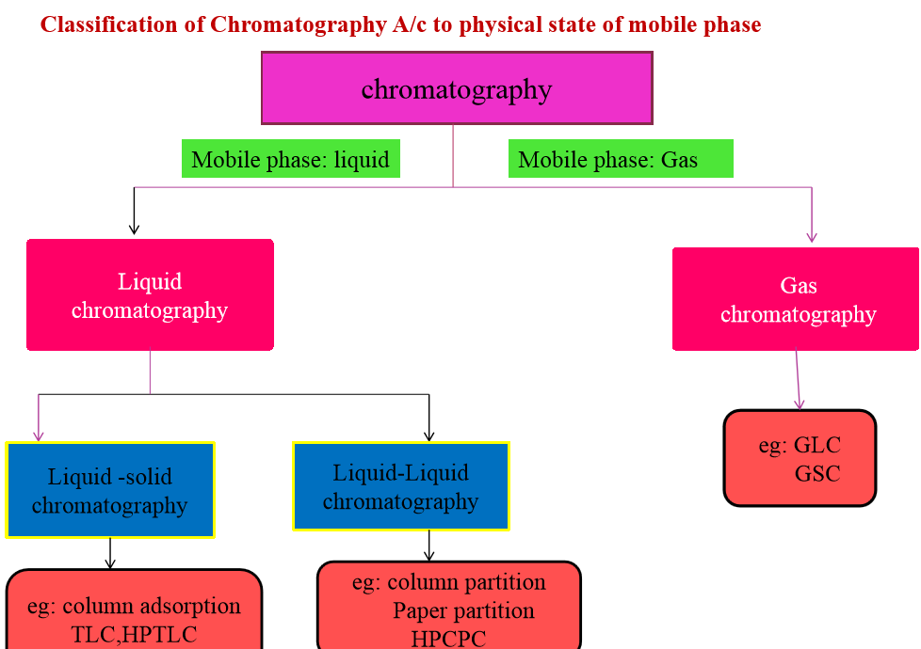
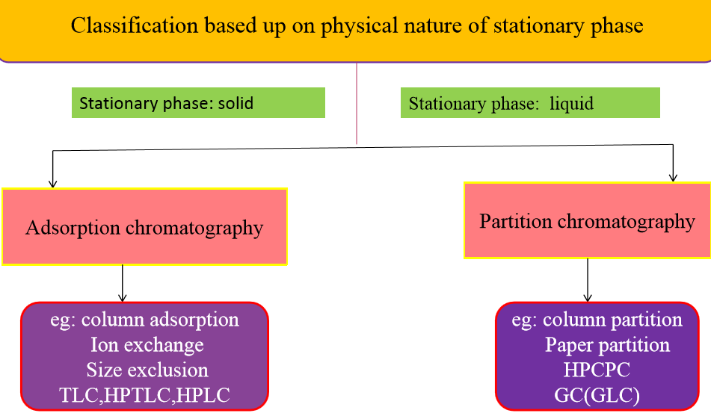
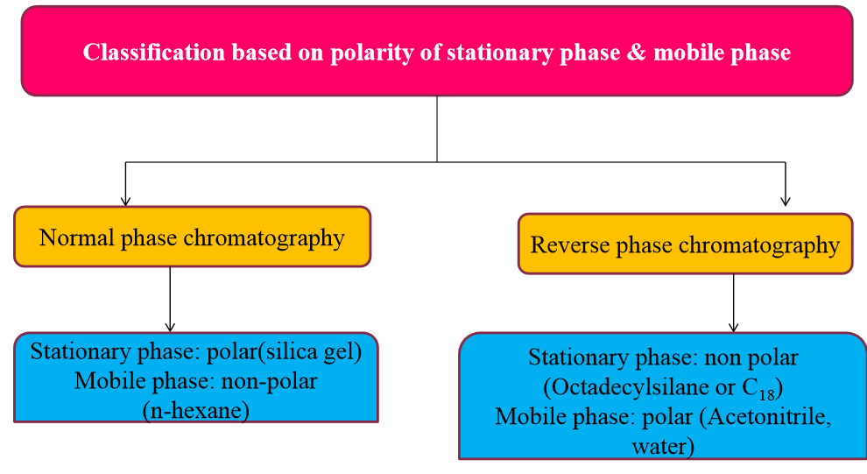
COLUMN CHROMATOGRAPHY
Column chromatography is a separation technique in which components of mixture are separated by using a glass column packed with stationary phase and the liquid mobile phase flowing continuously through the column.
Principles of column chromatography
Principles of column chromatography are based on Column adsorption chromatography, Partition chromatography, Ion-exchange chromatography, Size exclusion chromatography or Gel permeation chromatography.
Adsorption chromatography: The principle underlying the separation of the compounds is adsorption at the solid-liquid interphase. Solid stationary phase like silica gel and liquid mobile phase is used. In column chromatography the interaction between adsorbent & component is usually reversible. The separation is based on differences in affinities towards the stationary phase. The various components will move down the column until they are arranged in order of their affinity. Components with low affinity for adsorbent will move down the column at a faster rate than those with the greatest affinity for the adsorbent.
In normal-phase chromatography, four commonly used solvents are: hexane; dichloromethane; isopropanol; methanol (Increasing strength). In reverse-phase chromatography, four commonly used solvents are: water; methanol; acetonitrile; tetrahydrofuran (Increasing strength).
Mechanism of adsorption: In normal-phase chromatography, adsorption occurs due to hydrogen bonding and in reverse-phase chromatography adsorption occurs due to Vander walls interaction.
Partition chromatography: Distribution of solutes between two immiscible liquids. The two immiscible liquids are liquid stationary phase, liquid mobile phase or gaseous mobile phase. In partition chromatography separation is based upon the differences in partition coefficient of the individual components in a mixture. According to Nernst distribution law, the ratio of activities of the solute into two immiscible liquid phases is known as a partition coefficient.
Ion-exchange chromatography: Ion exchange chromatography is the process by which a mixture of charged ions can be separated using an ion exchange resin. The principle of separation is by reversible exchange of ions between the ions present in the solution.
Ion exchange resin-H + M⁺ Ion exchange resin-M⁺ + H⁺
Gel permeation chromatography: It is also called gel filtration or size exclusion chromatography. In size exclusion chromatography, the stationary phase is a porous matrix made up of compounds like cross linked polystyrene, cross linked dextran, polyacrylamide gels, agarose gels etc. The separation is based on their (analytes) molecular sizes since the gel behaves like a molecular sieve. This technique is used for the separation of proteins, polysaccharides, enzymes and synthetic polymers.

Requirements for column chromatography
- Column characteristics & selection
- Stationary phases
- Mobile phases
- Preparation of column
- Introduction of sample
- Development of column
- Detection of components
- Recovery of components
Column characteristics & selection: Following points should be considered for selection of suitable column.
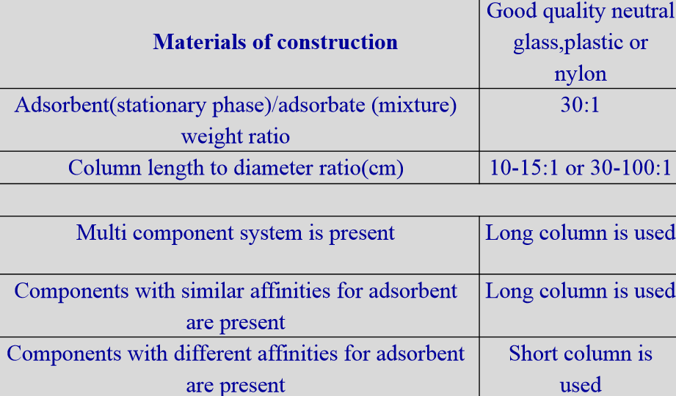
Stationary phases in column chromatography: Stationary phases used in column adsorption chromatography are also known as adsorbents. Requirements of an ideal stationary phase:
- They should be insoluble in solvents or mobile phases.
- Chemically inert.
- Colorless to facilitate observation of zones.
- Should have reproducible properties from batch to batch.
- The particle should have uniform size distribution and have spherical shape.
- Particle size: 60-200µ.
The most commonly used chromatographic adsorbent is silica or silicic acid or silica gel (80-100 mesh or 100-200 mesh size, which has a particle size of 63-200µm). They adsorb polar and unsaturated substances by the formation of hydrogen bonds with the hydroxyl groups on the silicon atom.
Adsorbents used in column chromatography are;
- Sucrose, starch, talc etc with weak activity
- Calcium carbonate, Calcium phosphate etc with medium activity
- Activated magnesium silicate, activated alumina, activated charcoal, activated silica etc. with strong activity
Mobile phases (eluents or solvents) in column chromatography: Mobile phase acts as a solvent to introduce the mixture into the column as developer to develop the zones for separation and as an eluent to remove the pure component out to the column.
Strain (1942) has arranged the solvents in order of eluting power. A grouping of solvents in order of chromatographic strength (polarity index) is known as elutrophic series.
Increasing eluting power: Petroleum ether > hexane > heptanes > Carbon tetra chloride > Cyclohexane > Carbon disulphide > Benzene > Toluene > Chloroform > Ether > Ethyl acetate > Acetone > Alcohols > Water > Pyridine > Organic acids > Inorganic acids & bases
Preparation (packing) of the column:
Slurry packing (wet packing method): The adsorbent is suspended in the mobile phase and stirred very well to remove all air bubbles. The resulted slurry is then poured in to the column. After slurry application, the column must be allowed to settle overnight. This is the ideal method of column packing. At the bottom portion of the column a piece of glass wool or cotton/whattman filter paper disc must be added before the slurry application.
Dry packing: In this method the dry adsorbent is poured to the column directly. Vibration is applied to get rid of air bubbles then the mobile phase is passed through the adsorbent. The demerit with this method is that air bubbles are entrapped between the solvent and the stationary phase. This method cannot be applied in gel chromatography.
Sample introduction in column chromatography:
Wet application: Dissolve the sample in the initial mobile phase and apply by pipette to the top of the column. This is very good method but in most of cases the samples are not soluble in the initial mobile phase.
Dry loading: Dissolve sample in any volatile solvent. The sample solution is then adsorbed on a small weight of adsorbent and the solvent is allowed to evaporate. The dry adsorbent loaded with the sample is then applied to the column.
Development of column: Removal of individual components from a column is called development of column.
Frontal analysis: This technique was developed by Tiselius in 1940. In this method, the solution of sample mixture is added continuously on the column. No mobile phase (solvent) is used for development of column. A mixture containing A, B, C is added on the column. If component A is least adsorbed, component B is adsorbed to intermediate extent and component C most strongly to the column adsorbent material, the least adsorbed A runs down the column fast, component B to intermediate extent while ‘c’ is retained at the top of the column.
Displacemental Analysis: In this method, a small volume of mixture is added to the column and elution is carried out by a solvent containing a solute which has adsorptivity for column material. The adsorbed constituents of mixture are displaced by the solute from mobile phase. Each solute in the mixture in turn displaces another substance solute which is less firmly adsorbed. The least adsorbed constituent is pushed out of the column. The substance used in mobile phase is called as displacer.
Elution analysis: It is a common method used in column chromatography. In this method a small volume of mixture to be separated is added on the top of column & mobile phase is allowed to flow through the column. The mixture introduced on the column gets separated into individual as the components of mixture are adsorbed to the column material to different extent. On other phase of mobile phase, each component of mixture is eluted out as separated components (called eluate).
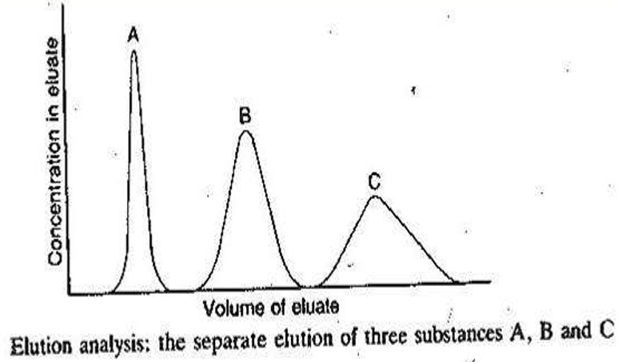
- Isocratic elution: In this elution technique, the same solvent composition or solvent of sample polarity is used throughout the process of separation. e.g. (chloroform only as a solvent or CHCL3 : MeOH =1:1)
- Gradient elution: In this elution technique, solvents of gradually increasing polarity or increasing elution length are used during the process of separation.
Detection & recovery of components: Fractions are collected by elution analysis. Each fraction is examined by TLC using suitable experimental conditions. Those fractions which give same Rf values in TLC are added as a common fraction. From the column fraction, solvent is evaporated, dried & the material is collected in eppendorf container. After spectral analysis (NMR, MS, X-RD etc.) the compound is identified
Factors affecting column efficiency: Following factors affect the column efficiency:
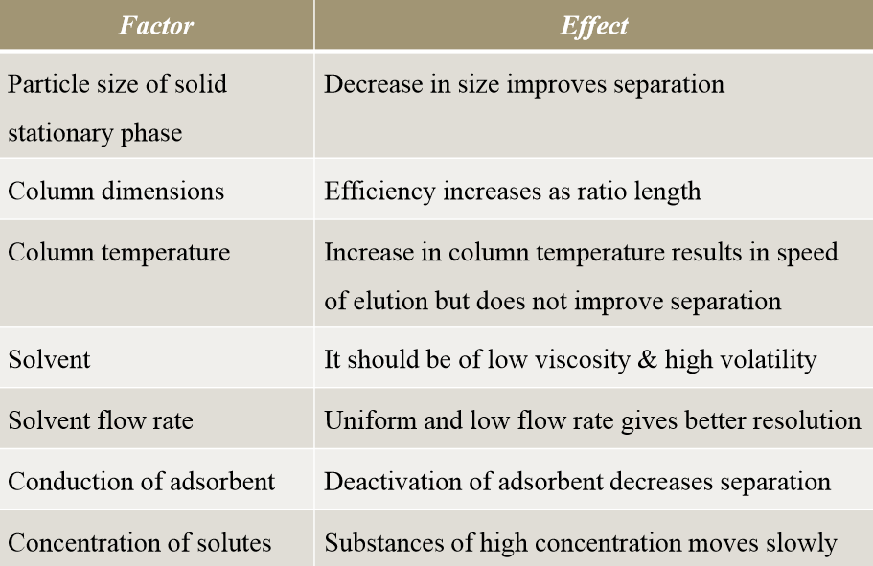
Applications of column chromatography
Column chromatography is a widely used separation technique in the pharmaceutical industry due to its versatility and effectiveness in isolating and purifying chemical compounds. Here are the primary applications:
Purification of Active Pharmaceutical Ingredients (APIs)
- Separating APIs from reaction mixtures to achieve high purity. E.g., Purification of vitamin-B12, oxytetracyclin and oleandomycin
- Removing impurities and by-products to meet regulatory standards.
Separation of Natural Products
- Isolating bioactive compounds from plant, microbial, or marine sources.
- Purifying alkaloids, glycosides, and flavonoids for drug development. E.g., Determination of primary and secondary glycosides in digitalis leaf
Quality Control and Assurance
- Analyzing the composition of pharmaceuticals to ensure consistency.
- Detecting and quantifying impurities in drugs.
Drug Discovery and Development
- Identifying and isolating lead compounds from complex mixtures.
- Screening for potential drug candidates in high-throughput settings.
Stability Studies
- Studying the degradation products of drugs under different conditions.
- Monitoring the stability of pharmaceutical formulations.
Peptide and Protein Purification
- Isolating and purifying biologics such as monoclonal antibodies, insulin, and vaccines.
- Ensuring high purity for therapeutic applications.
Pharmacokinetics and Metabolism Studies
- Analyzing drug metabolites in biological samples.
- Assessing how drugs are absorbed, distributed, metabolized, and excreted.
Reference Standard Preparation
- Producing high-purity compounds for use as reference standards in analytical methods.

