Volatile Oils

Definition
- Volatile oils or essential oils are the odorous principles found in various parts of plants. As they evaporate when exposed to air at ordinary temperature that is why they are called Volatile oils/essential oils.

- “Chemically volatile oils are mixtures of eleoptenes (the hydrocarbon portion of oil which is liquid) and one or more stearoptenes (the oxidized hydrocarbon portion of the oil which is solid)”.

Occurrence of volatile oils
They mainly occurs in specialized secretory structures
- Glandular hairs
e.g., Chammomile (Daisy)
- Oil cells
e.g., Cinnamon
- Secretion ducts (Vittae)
e.g., Anise
- Oil glands
e.g., Clove

Significance of volatile oils
- As flavoring agent e.g, oils of lemon.
- In perfumery e.g.,oil of rose.
- As starting material in the preparation of other compounds e.g., oil of turpentine.
- Volatile oils has carminative properties. A carminative, also known as carminativum (plural carminativa), is an herb or preparation intended to either prevent formation of gas in the gastrointestinal tract or facilitate the expulsion of said gas, thereby combatting flatulence.Example: Cinnamon
- Volatile oils with high phenolic contents act as antiseptic. Antiseptic are antimicrobial substances that are applied to living tissue/skin to reduce the possibility of infection, sepsis, or putrefaction. Example: Clove
- Volatile oils present in clove also have local anesthetic effects.
- Anthelmintics or antihelminthics are drugs that expel parasitic worms and other internal parasites from the body by either stunning or killing them and without causing significant damage to the host. Example: Chenopodium
- A counterirritant is a substance which creates irritation or mild inflammation in one location with the goal of lessening discomfort and/or inflammation in another location. Some volatile oils acts as counter irritants e.g., oil of wintergreen
- In plants they can act as insect repellent or insect attractant.Example: Juniper, Eucalyptus ( Insect repellent) and Lavender, Rosemary (Insect attractants)

Methods of obtaining volatile oils
Volatile oils can be obtained by different method

Distillation
Volatile oils can be prepared by the distillation of the plant parts containing the oil and method of distillation depends on the condition of plant material.

Water distillation
Water distillation is carried out if the plant material is dry and does not subject to injury on boiling. Crude plant material is introduced into the distilling chamber and then subjected to heat until all volatile matter both oil and water is condensed in the condensing chamber and oil layer is separated.
Example: Turpentine oil

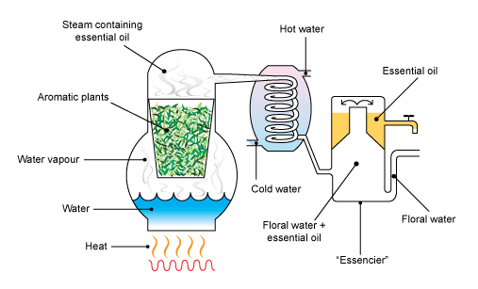

Water and steam distillation
If the plant materials are dried and fresh that may injured by boiling, then water and steam distillation process is preferred. Drug is grounded and is covered with a layer of water. Steam is passed through the macerated mixture. As oil can be impaired by the direct boiling so steam is generated elsewhere and is piped into the container holding the drug. Oily layer of condensed distillate is separated from the aqueous layer. Examples: Clove oil, Cinnamon oil

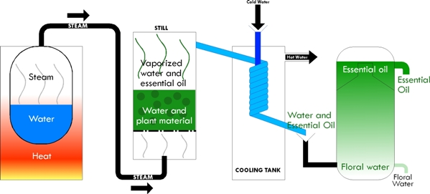

Direct steam distillation
In case of fresh plant material direct steam distillation process is carried out. In this method, crop is cut and placed directly into a metal distilling tank on a truck bed. Truck is driven to the distilling shed where steam lines are attached to the bottom of the distilling tank. Staem is forced to the fresh herb and carries oil droplets through a vapor pipes attached at the top of the tank to the condensing chamber. Examples: Peppermint oil, Spearmint oil

Destructive distillation
This method is used to obtain the “Empyreumatic oils”.Empyrheumatic oil is a oil abtained by distilling the volatile organic substance at high temperature. Having burnt nature or smell due to high temperature.In this method, wood part or resins of family Pinaceae is placed in a tank and heated without access of air, decomposition takes place and the number of volatile oils are driven off. Volatile oil contain two layers: An aqueous layer , It contains wood naphtha ( methyl alcohol) and pyroligneous acid( crude acetic acid) and Tarry layer, It contains pine tar and juniper tar or other tars depending upon the wood used.

Enzymatic Hydrolysis
- Specific enzymes are used to get volatile oil
- Glycosidic volatile oils are obtained by enzymatic hydrolysis of glycosides.
- Example: Sinigrin give allylisothiocyanate by the action of enzyme myrosin.
3

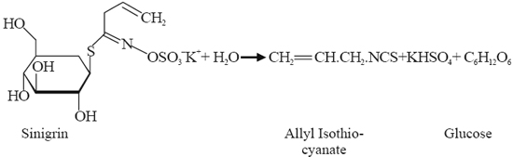

Extraction by scarification
This method is used for the preparation of oil of lemon and oil of orange. These oils are formed in large oil glands just below the surface in the peel of citrus fruit. The two principal methods of scarification are sponge and the ecuelle method.

Sponge process
In this process the content of the fruits are removed after making longitudinal or transverse cut, and the peel is been immersed in water for a short period of time. Then it is ready for expression. Then operator takes a sponge in one hand and with the other presses the softener peel against the sponge, so that the oil glands burst open and the sponge absorbs the exuded oil, which is transferred to a collecting vessel. The turbid liquid consisting of oil and water is allowed to stand for a short time, whereupon the oil separates from water and is collected.

Ecuelle process
In this process, the rinds are ruptured mechanically using numerous pointed projections with a rotary movement and the oil is collected.

Enfleurage
In this method volatile oil obtained from those plant parts which are very small and volatile oils are decomposed on distillation process. In such instances an odorless fat is spread in a thin layer on glass plates. The flower petals are spread on the fat for few hours; then a new layer of petals is introduced. After the fat has absorbed as much aromatic material as possible, the oil may be removed by extraction with alcohol.
This process is known as enfleurage and was formely used in the production of perfumes. Example: Rose Petals
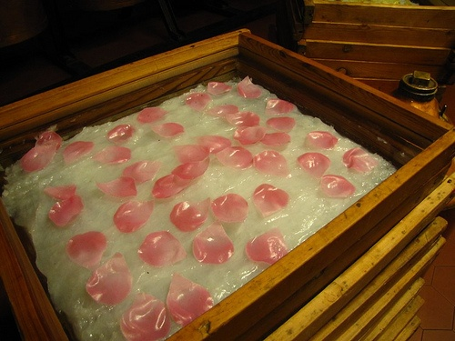

Extraction by volatile solvent
In this the flowers are extracted by using the solvent light petroleum and the latter is distilled off at a low temperature, leaving behind the volatile oil.

Chemistry of volatile oils

Terpenoids
- There are many different classes of naturally occurring compounds. Terpenoids also form a group of naturally occurring compounds majority of which occur in plants, a few of them have also been obtained from other source.
- Terpenoids are volatile substances which give plants and flowers their fragrance. They occur widely in the leaves and fruits of higher plants, conifers, citrus and eucalyptus.
- The simpler mono and sesterpene is the chief constituent of the essential oil obtained from sap and tissues from certain plant and trees.
The term terpene was originally employed to describe a mixture of isomeric hydrocarbons of the molecular formula C₁₀H₁₆ occurring in the essential oils.
- However there is tendency to use more broader term TERPENOIDS which include hydrocarbons and their oxygenated derivatives.
- According to the modern definition, Terpenoids are the hydrocarbons of plant origin of the general formula (C₅H₈) as well as their oxygenated, dehydrogenated and hydrogentaed derivatives.

Isoprene rule
Thermal decomposition of terpenoids gives isoprene as one of the product.
Isoprene rule states that the terpenoid molecules are constructed from two or more isoprene units.

Classification of terpenoids
Most natural terpenoid hydrocarbons have the general formula (C₅H8)n. They can be classified on the basis of number of carbon atoms present in the structure.

Hemiterpenoid
1 isoprene units, C₅H₈
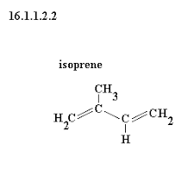

Monoterpenoid
2 isoprene units, C₁₀H₁₆
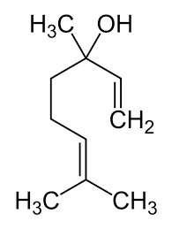

Linalol (Acyclic monoterpene)

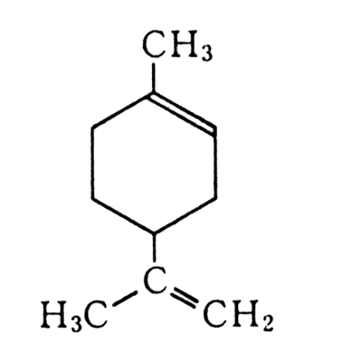
Limonene (Monocyclic monoterpene)

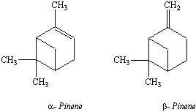

Bicyclic monoterpene

Sesquipenoid
3 isoprene units, C₁₅H₂₄
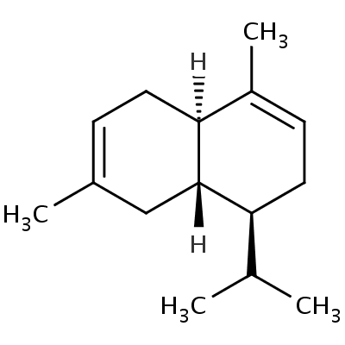
Cadinene
(Bicyclic sesquiterpene)

Diterpenoid
4 isoprene units, C₂₀H₃₂
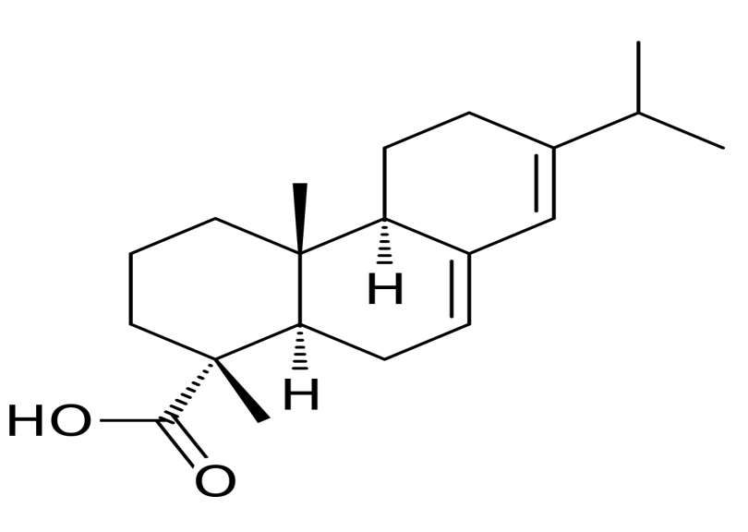
Tricyclic diterpene

Triterpenoid
6 isoprene units, C₃₀H₄₈
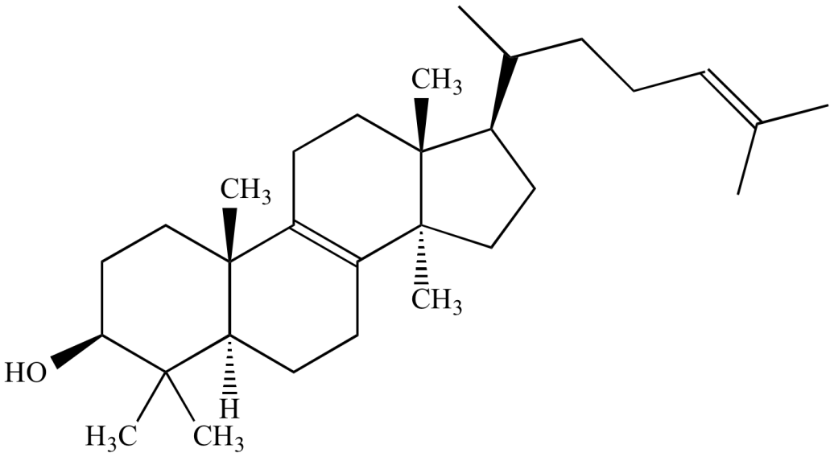
Lanosterol
(Tetracyclic terpenoid)

Tetraterpenoid
8 isoprene units, C₄₀H₆₄
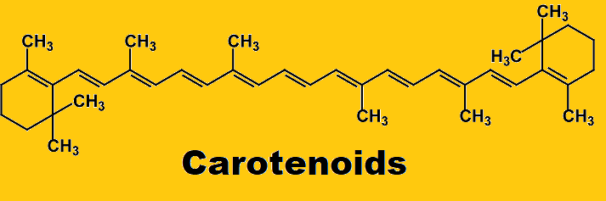

- Each class can be further subdivided into subclasses according to the number of rings present in the structure.
- Acyclic Terpenoids: They contain open structure.
- Monocyclic Terpenoids: They contain one ring in the structure.
- Bicyclic Terpenoids: They contain two rings in the structure.
- Tricyclic Terpenoids: They contain three rings in the structure.
- Tetracyclic Terpenoids: They contain four rings in the structure.

Chemical tests
- Thin section of drug on treatment with alcoholic solution of Sudan III develops red color in the presence of volatile oils.
- Thin section of drug is treated with tincture of alkana,which produces red color that indicates the presence of volatile oils in natural drugs.

Storage of volatile oils
- Volatile oils are liable to oxidation on storage in presence of air, moisture, and light. The oxidation is followed by the change in color, increase in viscosity, and change in odour.
- Hence, volatile oils must be stored in well-closed completely filled containers and away from light in cool places

Classification of volatile oils
Following are the divisions in which volatile oils and volatile oil containing drugs can be placed.(Based on the presence of functional group)

Hydrocarbon volatile oils

Cubeb

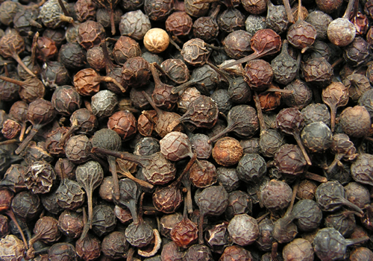

Biological source
Piper cubeba

Common name
Kabab chini

Family
Piperaceae

Part used
Dried fruits

Collection and preparation
- Fruits are collected when fully grown are green and dried under the sun.
- Drug is grounded and is covered with a layer of water.
- Steam is passed through the macerated mixture. As oil can be impaired by the direct boiling so steam is generated elsewhere and is piped into the container holding the drug.Oily layer of condensed distillate is separated from the aqueous layer.

Chemical constituents
Sabinene , 1,4-cineol, Cadinene , terpineol

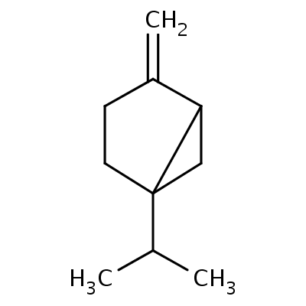

Sabinene Cadinene

Uses
- Antiseptic
- Stimulating expectorant

Turpentine oil

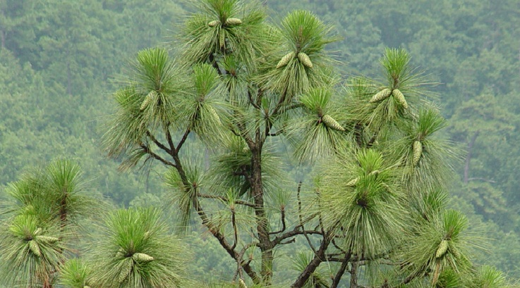

Biological source
Pinus longifolia

Common names
Long leaf pine

Family
Pinaceae

Part used
Oleoresin obtained from plant exudate

Collection and preparation
There are two methods for the collection of oleo-resin

Box method
It is very old method, which was previously used in many countries. A deep cut is made in the trunk of the tree and a box is placed beneath it, then blaze cuts are made on the trunk of tree. The length of which was increased from time to time. The oleoresin, which was collected in the box, was removed at intervals with a dipper and sent in barrels to the distillery.

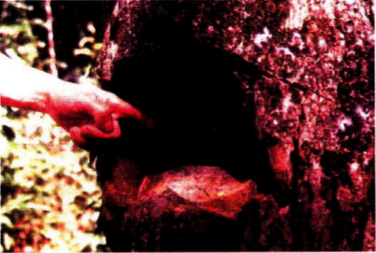

Cup and gutter method
A series of ‘V’ shaped incisions are made in the trunk of the tree. The bark and young wood being removed so that a blaze or a groove is formed in the trunk. At the base of incision and aluminium cup is fixed in the trunk and two strips of aluminium are inserted about to deflect the flow of oleoresin into the cup. The length of the blaze is increased and the cups are moved higher up the trees, As the cups become filled, their contents are emptied into the barrels, which are delivered to the distillery.
The oleoresin which are collected are transferred to copper stills, water is added and heated. The impurities like woody debris, and other particles float on the surface of water which is skimmed off. The clarified resin is then subjected to distillation for obtaining the oil. The oil obtained is then treated with aqueous solution of sodium hydroxide, which removes the traces of phenols, cresol and resin acids.
The oil which is produced then is called a Rectified Turpentine oil
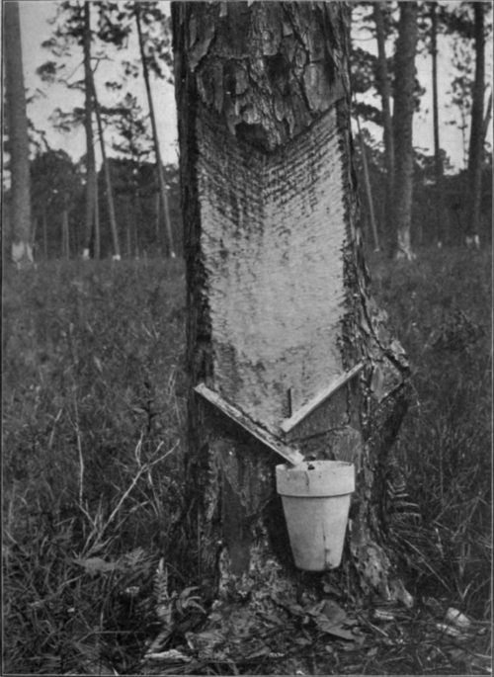
- Terpinol/Terpin hydrate is formed by the action of nitric acid on rectified turpentine oil in the presence of alcohol,stimulant to mucous membrane, so used as expectorant

Chemical constituents
Chief constituents are α-pinene and β-pinene, limonene and camphene.

Uses
- Counter irritant
- Rubefacient
- Swelling
- Mild antiseptic
- Expectorant
- Diuretic
- In industry used in the preparation of insecticides, paints ,varnishes etc.

Alcoholic volatile oils

Peppermint

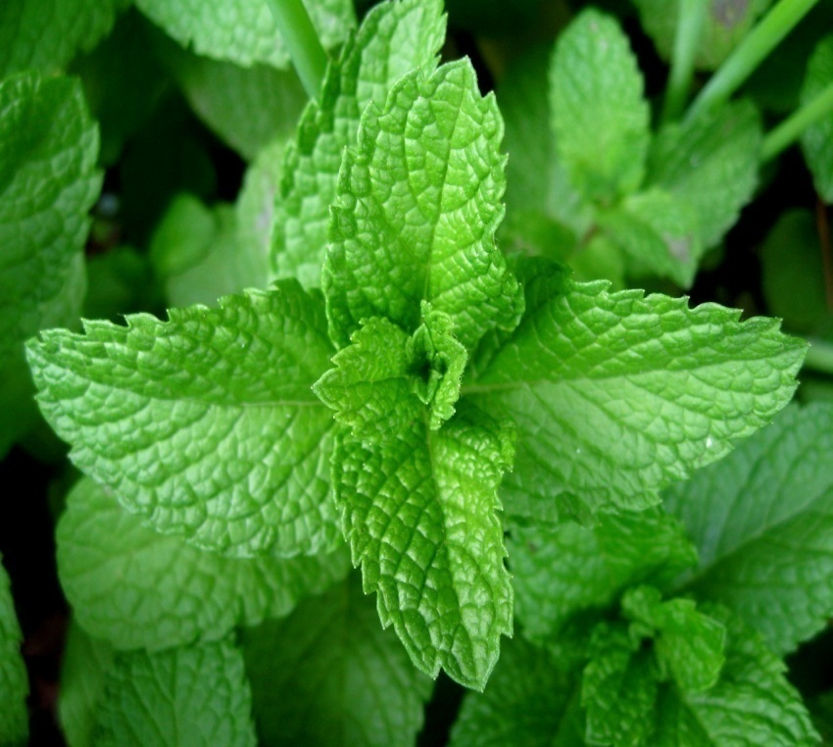

Biological source
Mentha piperita

Common name
Pudina

Family
Labiatae

Chemical constituents
Chief constituent of peppermint oil is menthol, along with other constituents like menthyl acetate, menthone, cineol, limonene

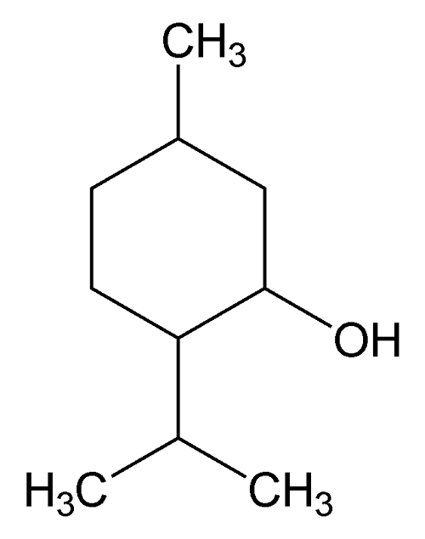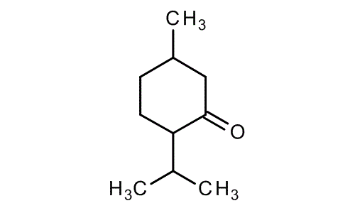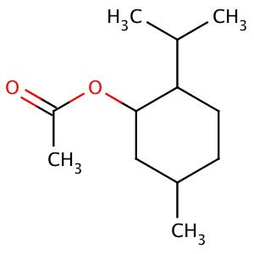

Menthol Menthone Menthyl acetate

Uses
- Flavoring agent, carminative, in abdominal cramps, in cholera,
- In diarrhea.
- Used in dental preparations and mouth washes
- In the treatment of cough
- Used in nervous disorders

Coriander

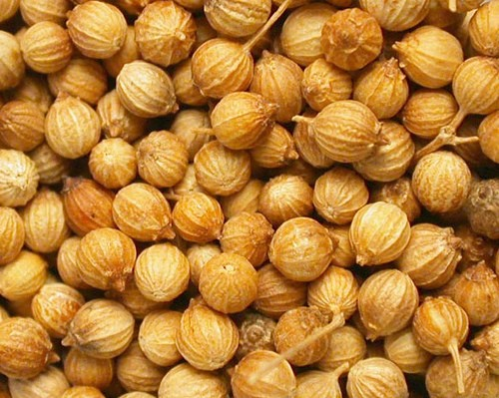

Biological source
Coriandrum sativum

Common names
Sokha dhaniya

Family
Umbelliferae

Part used
Dried ripe fruits

Chemical constituents
60%-70% linalol, limonene, α-pinene, cymene

Linalol

Uses
- Flavoring agent
- Carminative
- Soothes joint and muscle pain

Cardamom

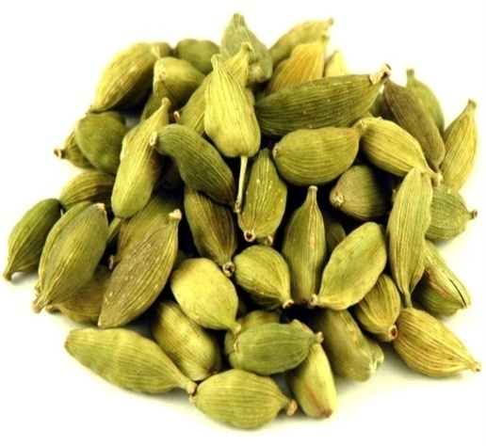

Biological source
Elettaria cardamomum

Common names
Sabz ilaichi

Family
Zingiberaceae

Part used
Dried, ripe seeds

Chemical constituents
Cineole (26-40%), α-terpinyl acetate, limonene, sabinene, linalyl acetate

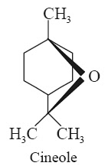

Uses
- Flavoring agent
- Carminative
- Supports weight loss
- Boosts digestive system

Aldehydic volatile oils

Bitter orange peel

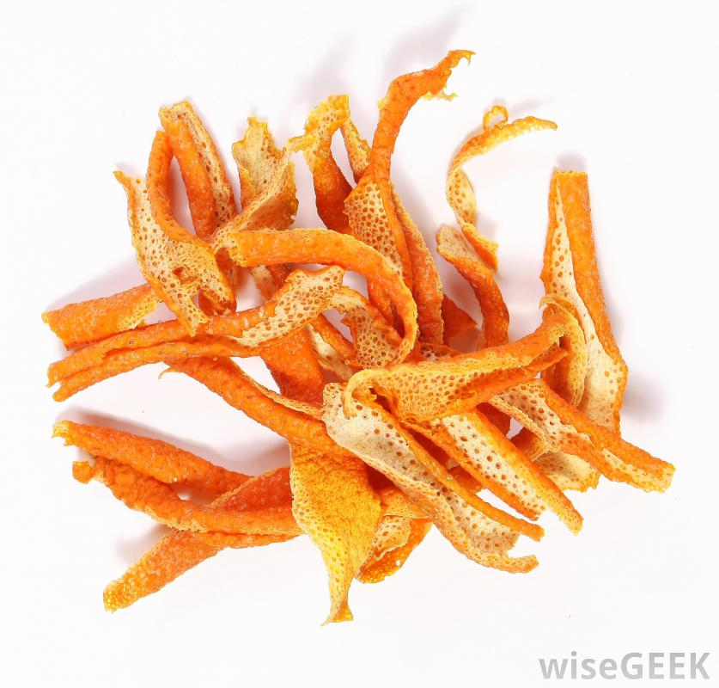

Biological source
Citrus aurantium

Family
Rutaceae

Part used
Fresh or dried peel

Chemical constituents
Bitter orange peel contains of 1 to 2.5% volatile oil. The chief component of volatile oil is 90% limonene and small quantities of aldehydes citral and citronellal. Bitter amorphous glycoside like aurantiamarin is present.

Limonene
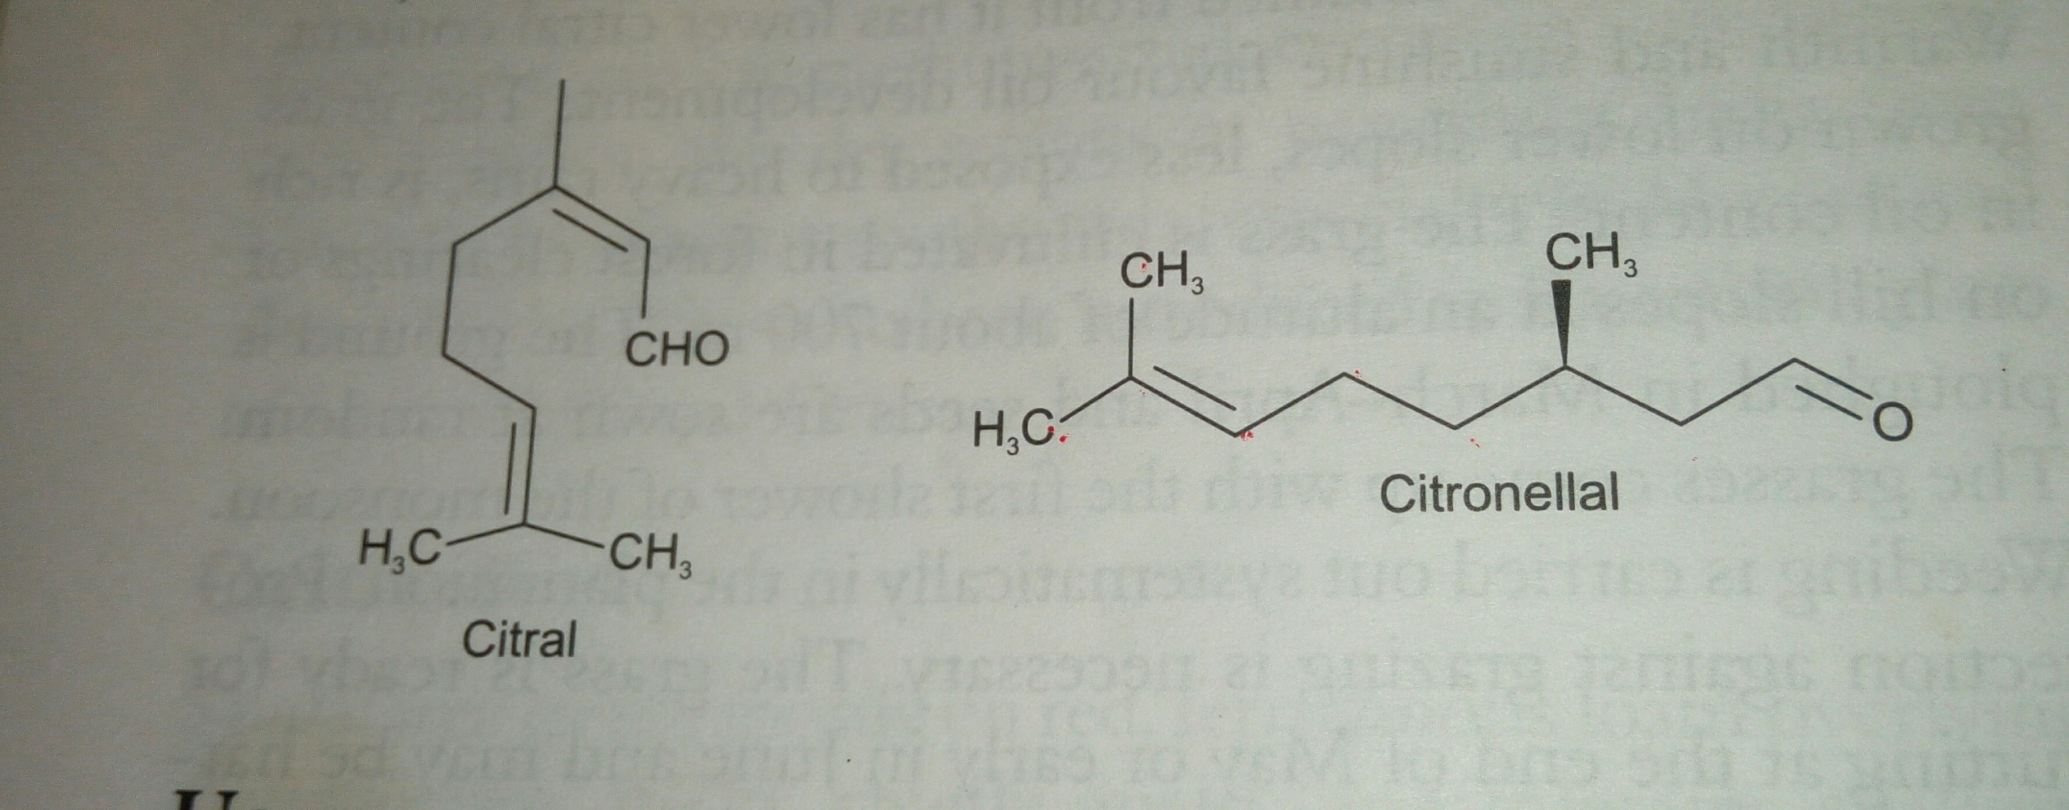

Uses
- Flavoring agent
- Carminative
- Stomachic

Sweet orange peel

Biological source
Citrus sinensis

Family
Rutaceae

Part used
Peel of fruit

Chemical constituents
Limonene 90%, citral 5%,

Uses
- Carminative
- Flavoring agent
- Fresh rind is rubbed on the face as the remedy for acne

Lemon peel

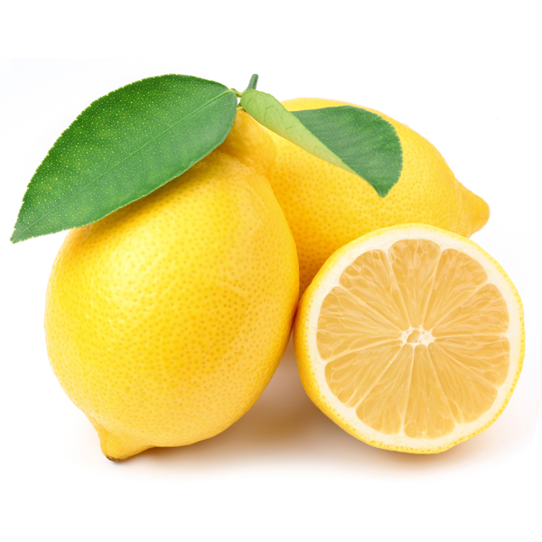

Biological source
Citrus limon

Family
Rutaceae

Part used
Peel from fresh ripe fruit

Chemical constituents
Volatile oils contains 90% limonene, citronellal, Linalol, camphene

Uses
- Stomachic
- Carminative
- Flavoring agent in medicines
- Used in cosmetic

Cinnamon

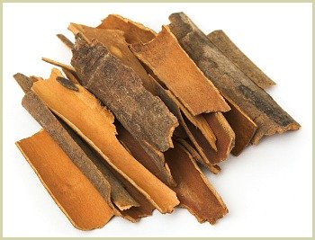

Biological source
Cinnamomum loureirii

Family
Lauraceae

Part used
Dried bark

Chemical constituents
Contains 10% volatile oils.Volatile oils contains 50-65% cinnamic aldehyde, along with 5-10% eugenol.
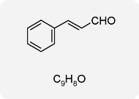

Cinnamic aldehyde

Uses
- Carminative
- Flavoring agent
- Antiseptic
- Analgesic
- It can be used for checking nausea and vomiting .
- Treatment of bronchitis, colds, congestion and liver problems.

Bitter almond oil

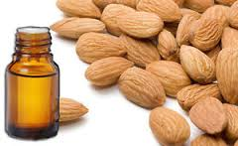

Biological source
Prunus amygdalus

Family
Rosaceae

Part used
Seeds

Chemical constituents
Chief constituent of bitter almond oil is fixed oil (50%), amygdalin (3-4%), enzyme (emulsin)

Preparation of bitter almond essential oil
The crushed kernels yield about 30-50% of a fixed oil similar to sweet almond oil. The powdered cake left after pressing, is then macerated in hot water and allowed to stand, the enzyme emulsin splits up amygdalin into dextrose, hydrocyanic acid and benzaldehyde. If steam be then passed through the mixture,the hydrocyanic acid and benzaldehyde distil over in combination as benzaldehyde- cyanohydrin.These form a heavy oil (essential oil of almond) which sinks in water.

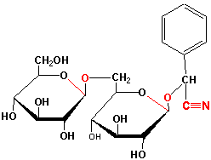

Amygdalin

Uses

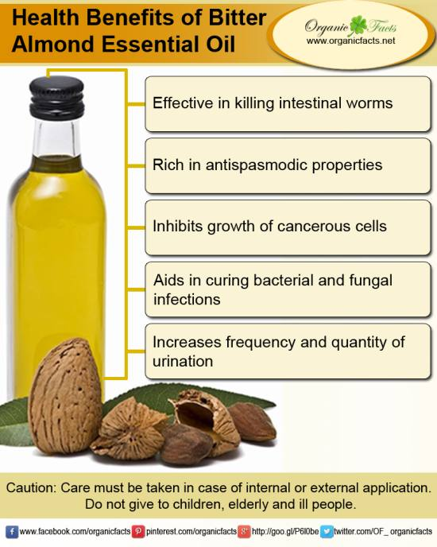

Ketonic volatile oils

Camphor

Biological source
Cinnamomum camphora

Family
Lauraceae

Part Used
Ketonic crystalline substance in the wood of tree

Collection
Old trees possess high concentration of camphor. The wood is cut into chips are treated with steam in distillation tank. Camphor is sublimed and liquid volatile oil passed away into the receiver. Excess of camphor is obtained from the volatile oil. Camphor is purified by treating it with lime and charcoal and after resublimation into large chambers to form Flowers of camphor, which can be made into blocks by hydraulic pressure.

Chemical constituents
Camphor oil contains camphor, cineole, pinene, camphene.

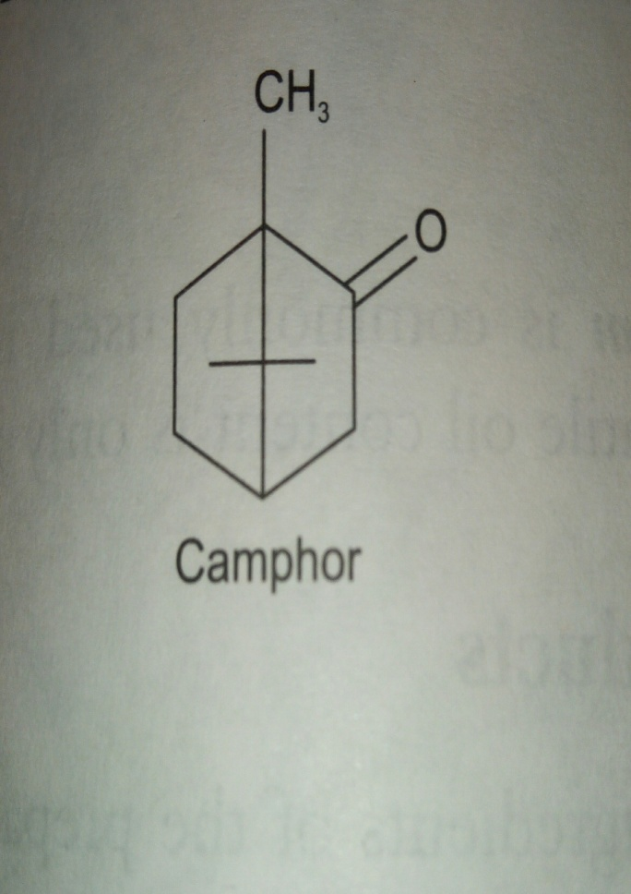

Uses
External uses are antipruritic, rubefacient and counter irritant, whereas internal uses are Antiseptic and carminative.

Spearmint

Biological source
Mentha spicata

Family
Labiatae

Part used
Dried leaves and flowering tops

Chemical constituents
Volatile oils contains (Carvone) 45-60%, limonene, phellandrene
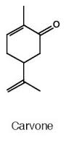

Uses
- Spermint oil possess carminative properties
- Used in chewing gum industries
- Also have spasmolytic and diuretic properties.

Caraway

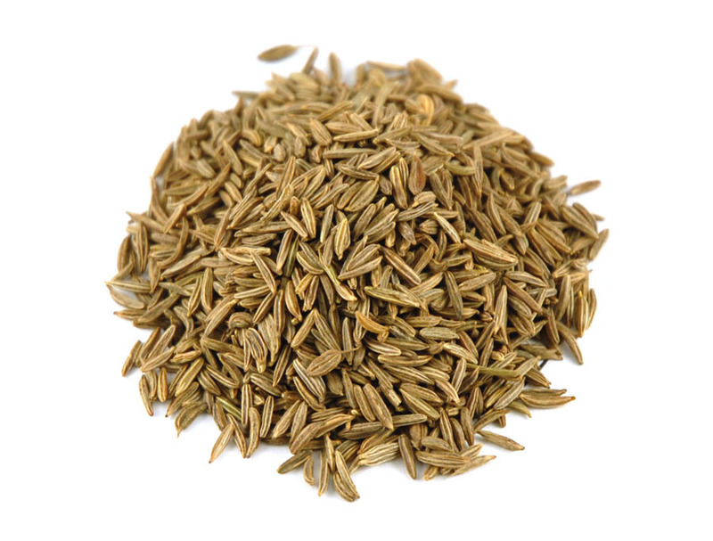

Biological source
Carum carvi

Family
Umbelliferae

Part used
Dried, ripe fruit

Chemical constituents
Volatile oil contains 50-60% carvone , carvacol and dihydrocarvone
Uses: Caraway is used as flavouring agent and as carminative,stomachic and for indigestion
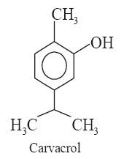

Buchu

Biological source
Barosma betulina

Family
Rutaceae

Part used
Dried leaf

Chemical constituents
1.5-3.5% volatile oils, which contains diosphenol, limonene,pulegone

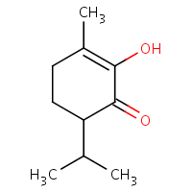
Diosphenol

Uses
- Urinary antiseptic
- Diuretic
- Carminative

Phenolic volatile oils

Clove

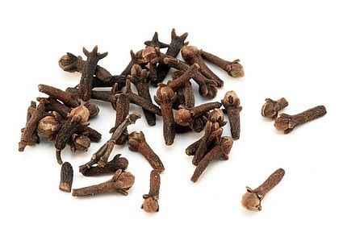

Biological source
Eugenia caryophyllus

Family
Myrtaceae

Part used
Dried flower buds

Chemical constituents
14-21% volatile oils, which contain eugenol 85-90%, acetyl eugenol 3%, β-caryophyllene.
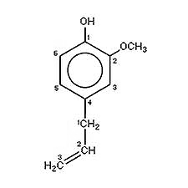
Eugenol

Uses
- Flavoring agent
- Toothache remedy
- Antiseptic
- Carminative
- Used in mouth washes

Thyme

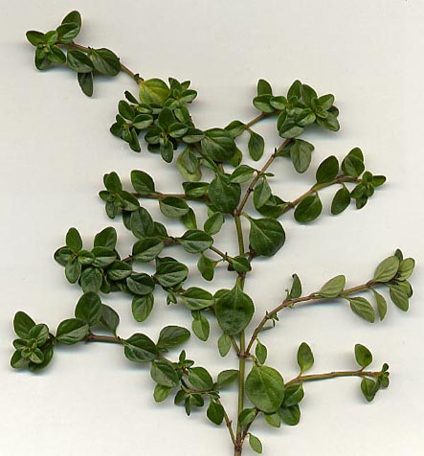

Biological source
Thymus vulgaris

Family
Labiatae

Part used
Dried leaves and flowering tops

Chemical constituents
Volatile oils consist of thymol, carvacol, β-cymene, α-Pinene, myrcene and linalol.
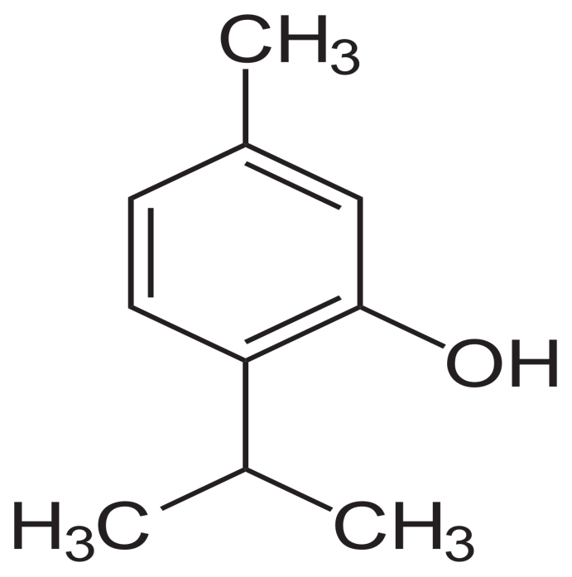

Thymol

Uses
- It has antiseptic, antifungal and antibacterial properties.

Volatile oils containing ethers

Fennel

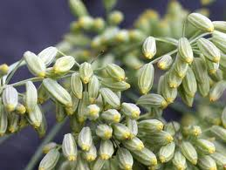

Biological source
Foeniculum vulgare

Family
Umbelliferae

Part used
Dried ripe fruit

Chemical constituents
4-5% volatile oils, which contains anethole (70%), fenchone (18-22%)
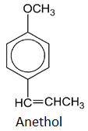
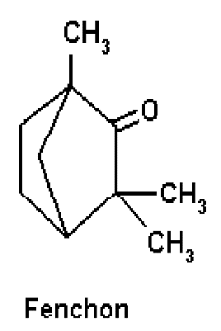

Uses
- Carminative
- Aromatic
- Colic pain
- Expectorant
- Flavoring agent,
- Antimicrobial
- Anti-inflammatory

Anise

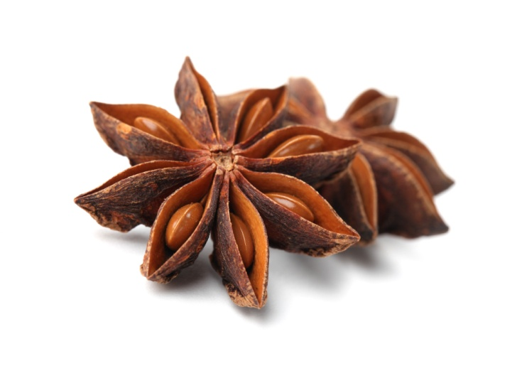

Biological source
Pimpinella anisum

Family
Umbelliferae

Part used
Dried ripe fruit

Chemical constituents
2.5-3.5% volatile oils, volatile oil contains anethole 90%, anisaldehyde, anisic acid, anisetone

Uses
- Diuretic
- Carminative
- Expectorant
- Aromatic
- Antispasmodic
- Digestive

Myristica

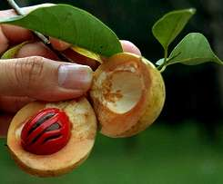

Biological source
Myristica fragrans

Common name
Nutmeg, Jaifal

Family
Myristicaceae

Part used
Seeds

Chemical constituents
5-15% volatile oils, volatile oils contains myristicin, borneol, geraniol, eugenol

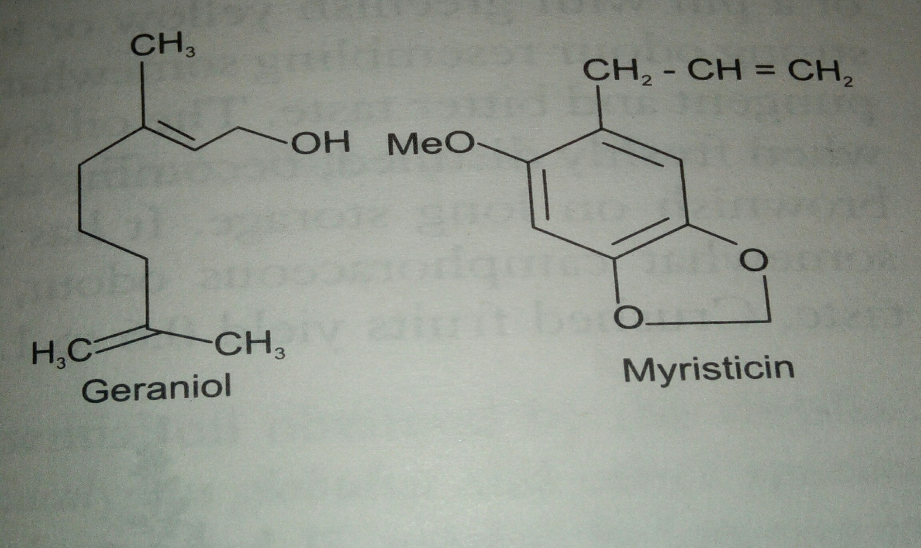

Uses
- Flavoring agent
- Carminative, antiflatulent, and to stop nausea and vomiting
- To conceal the taste of various drugs

Oxide volatile oils

Eucalyptus

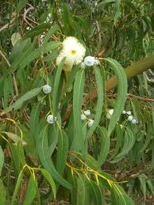

Biological source
Eucalyptus globulus

Family
Myrtaceae

Part used
Dried leaves

Chemical constituents
Volatile oil contains 70-85% cineol, p-cymene, α- pinene
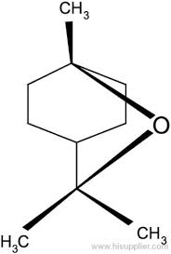

Cineole

Uses
- Antiseptic
- Aromatic
- Deodrants
- Expectorants
- Antispasmodic
- Beneficial in lung diseases,sore throat and various respiratory ailments

Chenopodium

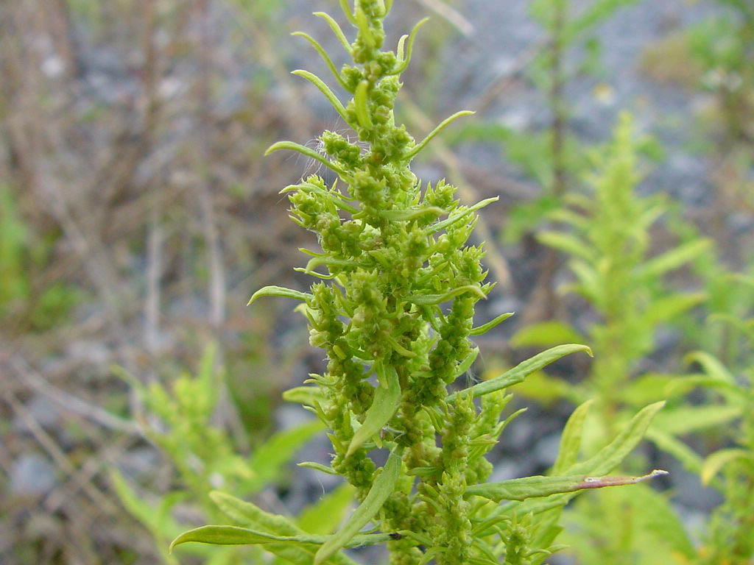

Biological source
Chenopodium ambrosioides

Family
Chenopodiaceae

Part used
Fresh aerial parts

Chemical constituents
Volatile oil contain 60-70% ascaridole, p-cymene
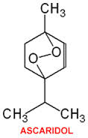

Uses
- It has antihelmentic properties, and is used in veterinary practice
- As purgative
- In treatment of malaria

Ester volatile oil

Rosemary
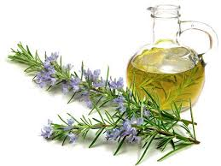

Biological source
Rosmarinus officinalis

Family
Lamiaceae

Part used
Flowers and flowering tops

Chemical constituents
1-2% volatile oils which conatins 0.8-6% esters, 8-20% alcohols, cineole, borneol, camphor , Bornyl acetate

Uses
- Flavoring agent
- Carminative
- Stimulant
- Perfumary.

Miscellaneous volatile oils

Garlic

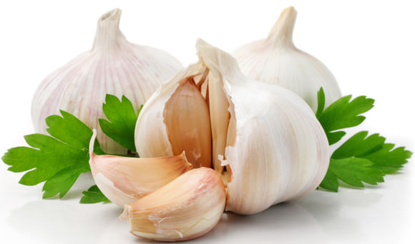

Biological source
Allium sativum

Family
Liliacaeae

Part used
Dried ripe bulb

Chemical constituents
Essential oil contains 0.06-0.1% essential oil contains allyl propyl disulphide, diallyl disulphide and allicin.

Uses
- Carminative
- Expectorant
- Used in atheroseclerosis and hypertension
- Aphrodiasic

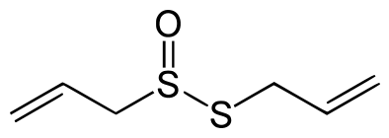
Allicin

Anethum

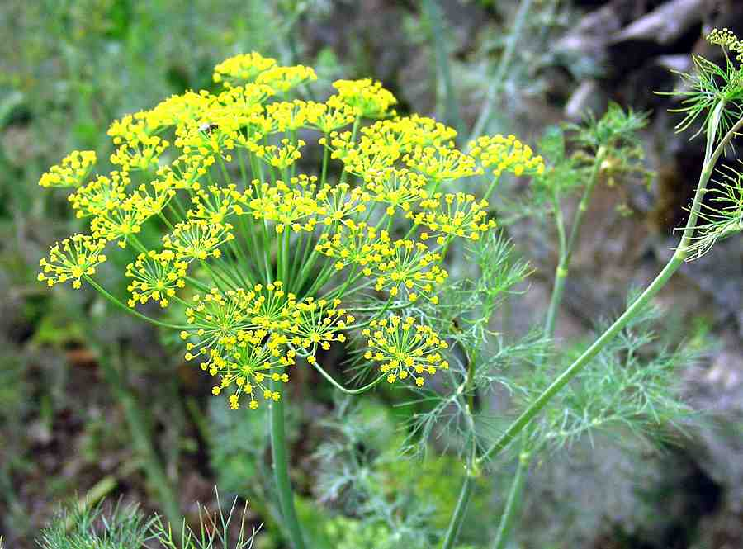

Biological source
Anethum graveolens

Family
Umbelliferae

Part used
Dried ripe fruit

Chemical constituents
3.5% volatile oils which contains 0.5% aliphatic compounds 40-60% carvone along with limonene

Uses
- Stomachic
- Diuretic
- Anthelmentic
- Antiflatulant
- For the preparations of gripe water
- Carminative

